LifeOS
(Structured Personal Life & Goal Management System)

Introduction
Purpose:
LifeOS is a web-based application designed to help users manage structured life boards such as Study, Career, Personal Growth, and Travel. The system provides goal tracking, deadline management, productivity scoring, and rule-based analytics

Scope:
- Allow user registration and authentication
- Provide predefined life boards
- Allow goal creation and tracking
- Calculate productivity metrics using rule-based logic
- Generate dashboard analytics
- Provide in-app notifications
- Be deployed as a cloud-based application

Users:
- Students
- Early-career professionals
- Individuals planning structured personal growth

USE CASE DIAGRAM:
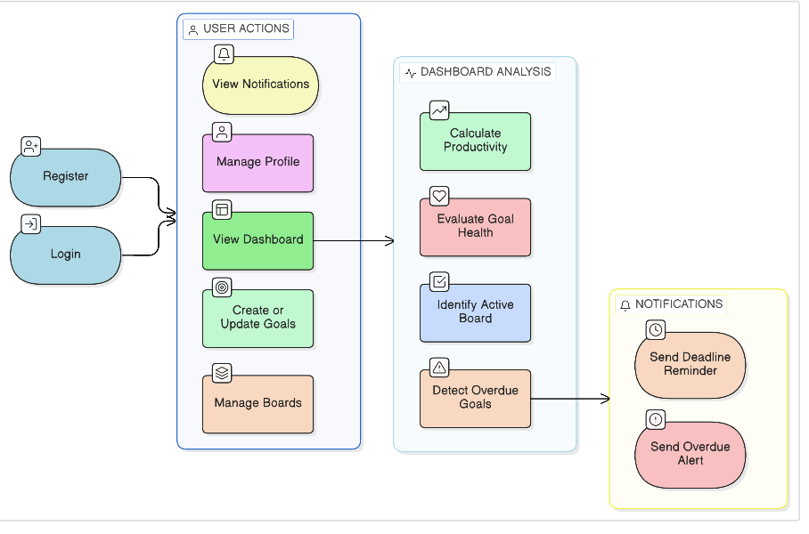

Requirements:
User Management

1: User Registration
The system shall allow new users to register using:
- Name
- Email
- Passwords
Passwords must be encrypted before storage.

2: User Login
The system shall authenticate users using email and password and generate a JWT token upon successful login.

3: User Logout
The system shall invalidate user session on logout (client-side token removal).

4: Profile Management
The system shall allow users to:
- View profile
- Update name
- Change password

3.2 Board Management

5: Default Board Creation
The system shall automatically create predefined boards upon first login:
- Study
- Career
- Personal Growth
- Travel

6: Create Custom Board
The user shall be able to create additional boards.

7: Edit Board
The user shall be able to rename boards.

8: Delete Board
The user shall be able to delete a board and all associated goals.

3.3 Goal Management

9: Create Goal
The system shall allow users to create a goal with:
- Title
- Description
- Priority (Low/Medium/High)
- Deadline
- Status (To-Do/In Progress/Completed)
- Progress Percentage

10: Update Goal
The system shall allow users to:
- Modify details
- Update progress %
- Change status

11: Delete Goal
The system shall allow users to delete goals.

12: Overdue Detection
The system shall automatically mark goals as overdue if:
- Current date > deadline
- Status ≠ Completed
3.4 Dashboard & Analytics

13: Dashboard Overview
The system shall display:
- Total Goals
- Completed Goals
- Pending Goals
- Overdue Goals
- Upcoming Deadlines

14: Productivity Score Calculation
The system shall calculate productivity scores using a rule-based formula:
Example: (Productivity Score) = (Completed Goals / Total Goals × 100) – (Overdue Goals × penalty factor)
15: Goal Health Score
The system shall determine goal health based on:
- Progress %
- Deadline proximity
- Priority
Health levels:
- Good
- Moderate
- At Risk
16: Most Active Board Detection
The system shall calculate the board with highest activity using activity logs.

17: Weekly Activity Summary
The system shall generate weekly summary including:
- Goals created
- Goals completed
- Overdue count
Level | Input Type
User | Name, Email, Weekly Focus
Board | Type, Name
Goal | Priority, Deadline, Progress
System | Auto fields (Created, Updated, Overdue)
Analytics | Derived from DB queries

